Fine-Tuned Local Small Language Model for Robust and Explainable Short-Answer Grading via the Key-Point Scoring Framework

Symbat Nurgaliyeva  School of Software Engineering  Astana IT University  Astana, Kazakhstan  symbat.nurgaliyeva@astanait.edu.kz  ORCID: 0009-0009-5880-6166 | Gani Uapov*  School of Software Engineering  Astana IT University  Astana, Kazakhstan  255786@astanait.edu.kz  ORCID: 0009-0003-5123-6830

Abstract— Manual grading of short constructed answers is a persistent bottleneck in engineering education, while many existing automated graders are shallow, opaque and easily manipulated. This study develops and validates a fine-tuned local small language model (Llama-3-8B) that grades short science answers and produces transparent, criterion-referenced feedback through the Key-Point Scoring Framework. The model is trained by knowledge distillation from a larger teacher model and evaluated only on the official held-out SciEntsBank splits using quadratic weighted kappa with bootstrap confidence intervals. The fine-tuned model reaches substantial agreement (kappa 0.61–0.69), close to the human reliability ceiling, and clearly outperforms sentence-embedding baselines and a zero-shot large model. The study further shows that all graders share a keyword-stuffing vulnerability that prompt engineering cannot remove, whereas balanced adversarial training largely neutralises it without harming clean accuracy, yielding a cheap, private and explainable grader.

Keywords— automated short-answer grading; small language models; knowledge distillation; low-rank fine-tuning; key-point scoring; quadratic weighted kappa; adversarial robustness

Introduction
Short constructed-response items require students to connect concepts with reasoning in their own words, capturing aspects of understanding that multiple-choice questions cannot reach. In engineering and science courses, however, grading such answers by hand at scale is slow, costly and inconsistent between graders, which makes short-answer items difficult to use in large cohorts and in formative settings where fast feedback matters most. Automated short-answer grading (ASAG) offers a structural solution and remains an active research problem [1].
A high classification score alone does not make a grader fit for a real syllabus. To be trusted in teaching, a grader must be valid, in that it measures the correctness of meaning rather than surface form; interpretable, so that a teacher can see why a grade was given; and safe from manipulation by students who learn its weaknesses. Building on these requirements, this study targets a grader that is simultaneously cheap, private, interpretable and robust, and that can run locally without sending student data to an external service.
This study makes the following contributions. (1) A clean, leakage-free evaluation protocol on the official SciEntsBank splits, with a corrected label mapping and bootstrap confidence intervals. (2) A fine-tuned local eight-billion-parameter model that produces structured key-point feedback and reaches substantial agreement, outperforming sentence-embedding baselines and a zero-shot seventy-billion-parameter model. (3) Evidence that zero-shot large models systematically under-grade by hedging toward the middle class, a calibration failure that fine-tuning corrects. (4) A demonstration that all evaluated methods, including the structured fine-tuned model, are vulnerable to keyword stuffing, and that prompt hardening does not solve it. (5) A balanced adversarial-training defense that largely neutralises the attack and improves grading under attack at negligible cost to clean accuracy.

Related Work

Automated Short-Answer Grading
Earlier ASAG systems combine lexical and semantic features, for example bag-of-words signals with sentence embeddings [9], and recent work evaluates generative large models on open-ended questions with mixed reliability [10]. Fine-tuned models tend to outperform prompted or zero-shot large models on strict grading [6]. A systematic review of intelligent assessment systems for engineering education, which screened 489 records and included 56 studies published between 2020 and 2025, frames the tensions addressed in this work and motivates a grader that is valid, interpretable and robust rather than only accurate.

Measurement Biases and Adversarial Robustness
Similarity-based graders reward answers that contain the right terms without the right meaning — a lexical-matching bias formalised as the Anna Karenina effect in embedding spaces [3]. Automated graders are demonstrably foolable by surface manipulation such as inserting empty adjectives and adverbs [4, 5]. Finally, agreement must be interpreted against the human reliability ceiling rather than against a perfect score, because even expert graders disagree on longer and more complex answers [8].

Explainability and the Key-Point Scoring Framework
Transparency through human-readable reasoning is needed for trust, as in explainable grading frameworks that expose found and missing content [7]. The Key-Point Scoring Framework (KPSF) responds to several of these points by segmenting a reference answer into labelled components and generating criterion-referenced feedback rather than only a terminal grade [2]. The present study operationalises KPSF inside a fine-tuned local model and tests whether its structure confers robustness in addition to interpretability.

Materials and Methods

Dataset and Splits
All experiments use SciEntsBank from the SemEval-2013 Task 7 Student Response Analysis corpus, comprising roughly 11,000 responses to 197 science questions across fifteen domains [11]. Three official held-out test splits measure increasing generalisation difficulty (Table I): unseen answers to seen questions, unseen questions and unseen domains. All reported metrics use these held-out splits only.
TABLE I. OFFICIAL HELD-OUT TEST SPLITS
Split | Size | Generalisation regime
test_ua | 540 | Unseen answers to seen questions (easiest)
test_uq | 733 | Unseen questions (harder)
test_ud | 4562 | Unseen domains (hardest, true generalisation)

Label Scheme and a Corrected Mapping
The corpus uses five labels, which are collapsed here into an ordinal three-level proficiency scale (Incorrect, Partial, Correct). A latent bug was identified in the original pipeline: the dataset's integer order places correct=0, contradictory=1, partially_correct_incomplete=2, irrelevant=3 and non_domain=4, whereas the original code assumed 1=Partial and 2=Incorrect, which scrambled two classes. The corrected pipeline maps by class name rather than by integer (Table II); all wrong-answer types fold into Incorrect, while Partial is retained as a genuine middle level.
TABLE II. ORDINAL LABEL COLLAPSE (MAPPED BY CLASS NAME)
Source label (5-way) | Ordinal | Meaning
correct | 2 | Correct
partially_correct_incomplete | 1 | Partial
contradictory | 0 | Incorrect
irrelevant | 0 | Incorrect
non_domain | 0 | Incorrect

Data Integrity
The training pool was de-duplicated on (question, answer) pairs, reducing 4,969 to 4,827 examples (142 duplicates removed), and 24 (question, answer) pairs overlapping with the test splits were removed, confirming that an earlier in-train test slice had been contaminated. Fig. 1 summarises the full workflow of data preparation, distillation, fine-tuning, evaluation and robustness testing.
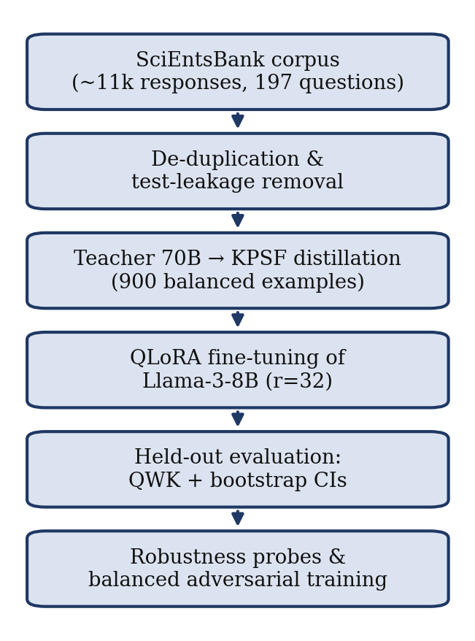
Fig. 1. Workflow of data preparation, distillation, fine-tuning, evaluation and robustness testing.

Knowledge Distillation
A balanced training set was annotated by a larger teacher model (Llama-3.3-70B) that produced structured output in the Key-Point Scoring Framework format, containing the extracted key points and the feedback. The final score is anchored to the true SciEntsBank label, so the teacher rationalises a known answer rather than guessing freely, and the teacher is forbidden from stating the numeric grade inside the feedback; this reduced score leakage into the feedback text from 360 to 3 cases out of 900.

Output Format and Explainability
For each answer the student model emits a JSON object in which the key points are listed first, the formative feedback is written next and the ordinal score is produced last. Placing the reasoning before the score gives a lightweight chain of thought and an explicit account of which key points were found or missed — a transparent alternative to post-hoc attribution methods [7].

Fine-Tuning Configuration
The base model is an eight-billion-parameter Llama-3 instruction model [13], fine-tuned with quantised low-rank adaptation (QLoRA) [14, 15]. Table III lists the hyperparameters; training converged without overfitting (training loss ≈ 0.22, validation loss ≈ 0.34).
TABLE III. FINE-TUNING CONFIGURATION
Setting | Value
Base model | Llama-3-8B-Instruct, 4-bit quantisation
Method | QLoRA; LoRA rank r = 32, alpha = 64, dropout = 0
Target modules | q, k, v, o, gate, up and down projections
Optimisation | learning rate 5e-5; effective batch 8; 3 epochs
Sequence / precision | max length 2048; bfloat16; Llama-3 chat template
Hardware | single consumer GPU (NVIDIA T4 / L4)

Evaluation Protocol
The primary metric is quadratic weighted kappa on the ordinal labels {0, 1, 2}, which penalises errors by the squared ordinal distance so that a two-step error is far worse than a one-step error:
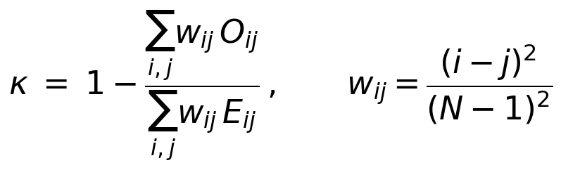
where O is the observed agreement matrix, E the expected matrix under independence and N the number of categories. Decoding is greedy (temperature 0) for determinism, and 95% confidence intervals are obtained from a 1,000-sample bootstrap. The sentence-embedding baselines, the base model, the fine-tuned model and the teacher model are all evaluated on identical items under the same three-way scale [12].

Results and Discussion

Comparative Performance
Table IV reports the kappa of every method on the three official splits. Two Sentence-BERT (SBERT) baselines [12], a cosine-similarity scorer and a trained classifier, stay far below every large-model method, and their confidence intervals do not overlap. The fine-tuned model reaches a mean kappa of 0.669, above the base model's 0.595 and well above the teacher's 0.532; the gain from fine-tuning is largest on unseen answers (+0.166) and negligible on unseen domains (+0.011). Because even the untuned base model already exceeds the 70B teacher, the result is read conservatively: the defensible claim is that the fine-tuned local 8B is the strongest grader overall — vastly outperforming embeddings and giving a consistent gain over the same model without training — rather than a blanket claim that an 8B model is intrinsically stronger than a 70B model. Fig. 2 visualises the comparison against the human reliability ceiling.
TABLE IV. QUADRATIC WEIGHTED KAPPA ON THE OFFICIAL TEST SPLITS
Method | ua | uq | ud | Mean | 95% CI
SBERT, cosine | 0.254 | 0.356 | 0.245 | 0.285 | —
SBERT, classifier | 0.305 | 0.414 | 0.272 | 0.330 | —
Base-8B (zero-shot) | 0.523 | 0.671 | 0.592 | 0.595 | ua [.40,.63]
Fine-tuned 8B (ours) | 0.689 | 0.714 | 0.603 | 0.669 | ua [.61,.76]
Teacher-70B (zero-shot) | 0.542 | 0.549 | 0.504 | 0.532 | —
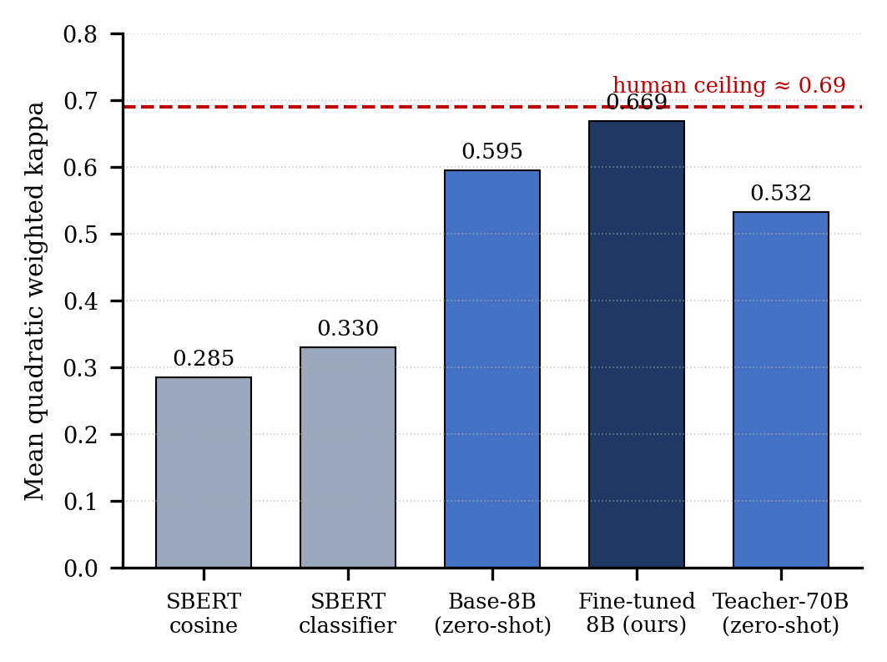
Fig. 2. Mean quadratic weighted kappa by method, with the human inter-rater ceiling (≈ 0.69) shown for reference.

The Zero-Shot Hedging Phenomenon
The teacher's modest kappa is explained by a strong bias toward the middle class: across the three splits it recognises only about 12 of roughly 84 truly-correct answers per split and assigns most responses to Partial. This under-grading is a second face of measurement bias — the mirror image of the lexical over-grading examined below — and fine-tuning calibrates the model to the real grade distribution, removing the bias.

Error Structure
Evaluated on the full official splits, the fine-tuned model attains kappa of 0.694, 0.652 and 0.608 with accuracy near 0.61 (Table V). The key observation is that 94–98% of predictions fall in the exact or an adjacent category, and catastrophic two-step (Incorrect to Correct) errors are only 2.4–5.7%. This is why kappa is high while accuracy is moderate: almost all errors are off by one and therefore pedagogically safe. Degradation across difficulty is graceful and monotonic (0.69 > 0.65 > 0.61), which is evidence of substantive generalisation to unseen domains. The remaining weak spot is the Partial class, whose precision (0.31–0.35) reflects the model's tendency to hedge toward the middle under uncertainty.
TABLE V. FINE-TUNED MODEL ON THE FULL OFFICIAL SPLITS
Split | Kappa | 95% CI | Accuracy | 2-step err.
test_ua | 0.694 | [0.646, 0.742] | 0.635 | 2.4%
test_uq | 0.652 | [0.607, 0.692] | 0.617 | 2.9%
test_ud | 0.608 | [0.562, 0.645] | 0.607 | 5.7%

Robustness
Two perturbations test whether a method scores meaning or surface form, neither of which changes the actual correctness of an answer. P1 inserts empty intensifiers (a padding attack), and P2 injects reference key terms into a wrong answer without making it correct (keyword stuffing); a robust grader should not change its prediction. P1 barely moves any method (the fine-tuned model's kappa changes by about −0.003). P2, however, fools every method, including the structured fine-tuned model: under keyword stuffing the fine-tuned model inflates about 54% of wrong answers and loses roughly 0.27 kappa, comparable to the embedding baselines (inflation 0.57–0.64). The structured Key-Point Scoring Framework therefore does not confer robustness, because its key-point check is itself partly lexical. Even under attack, however, the fine-tuned model still holds a kappa of about 0.39 — above the clean performance of the embedding baselines.

Mitigation
Table VI traces the full defense arc (means over splits). Targeted prompt hardening — instructing the model to award a key point only for a coherent, correct explanation and to treat keyword lists as missing the point — reduced inflation only modestly (0.544 to 0.480) and did not recover grading under attack, so prompt engineering alone is insufficient. Adversarial training was then applied. A naive version that added stuffed examples only to wrong answers eliminated inflation entirely but over-corrected: it learned the shortcut that injected keywords imply Incorrect and penalised any keyword-dense answer, collapsing under-attack kappa to 0.125. A balanced version that also added stuffing to correct answers, kept correct, resolved the trade-off, halving inflation (0.55 to 0.23), improving grading under attack (kappa 0.44 to 0.51) and costing almost nothing on clean data (0.674 to 0.658).
TABLE VI. ROBUSTNESS AND THE FULL MITIGATION ARC (MEAN OVER SPLITS)
Condition | Kappa clean | Kappa under P2 | Inflation
Original (no defense) | 0.674 | 0.437 | 0.551
+ hardened prompt | 0.658 | 0.390 | 0.480
+ adv. training (naive) | 0.666 | 0.125 | 0.000
+ adv. training (balanced) | 0.658 | 0.507 | 0.231

Human Reliability Ceiling
Agreement should be read against human performance rather than a perfect score. By the standard interpretation of kappa, values of 0.61–0.80 indicate substantial agreement and 0.41–0.60 moderate agreement [16, 17]. For the sibling Beetle subset of the same corpus, reported human inter-rater agreement is about 0.69 [8]. The fine-tuned model's kappa of 0.61–0.69 therefore lies inside the substantial band and is on par with human inter-rater agreement on a closely related dataset, indicating that the grader approaches human-level reliability. Two caveats apply: human agreement is usually reported as unweighted kappa whereas this work reports quadratic-weighted kappa, so the figures should be compared within the same metric family; and a SciEntsBank-specific human figure should be preferred when available, with Beetle as the closest published proxy.

Synthesis
The findings line up with the tensions raised in the review. A fine-tuned local model can give criterion-referenced key-point feedback, not just a terminal grade; lexical matching inflates 54–64% of wrong answers across methods, while a zero-shot large model fails in the opposite direction by under-grading. Every grader proved manipulable, and where prompt fixes fall short, balanced adversarial training helps. Transparency comes from the design itself — the explicit list of found and missing key points — and, once read against the human ceiling, the agreement is substantial.

Conclusion
A small, local, open-source language model, fine-tuned by knowledge distillation and producing structured key-point output, grades short science answers at substantial agreement (kappa 0.61–0.69), close to human reliability, and decisively outperforms classical sentence embeddings and a zero-shot large model, while keeping almost all errors within one ordinal level and making its reasoning explicit. A shared vulnerability to keyword stuffing is diagnosed across all methods and is largely mitigated by balanced adversarial training without sacrificing clean accuracy. Rather than a single best-case figure, the study offers an empirically grounded validation — and partial resolution — of the central problems raised in the systematic review, using a model that is cheap to run, keeps student data local, and is interpretable enough for classroom use in engineering education. Future work includes calibrating the Partial class through confidence thresholds or abstention, combining the key-point check with an independent entailment check to resist lexical injection, scaling adversarial robustness with explicit transfer to unseen domains, and a direct human-ceiling study on SciEntsBank.

References
[1] B. E. Clauser, V. Yaneva, P. Baldwin, et al., "Automated scoring of short-answer questions: a progress report," Applied Measurement in Education, vol. 37, no. 3, pp. 209–224, 2024.
[2] H. Wang et al., "LLMarking: adaptive automatic short-answer grading using large language models," in Proc. 12th ACM Conf. Learning @ Scale (L@S '25), 2025, pp. 105–115.
[3] A. G. Schleifer, B. Beigman Klebanov, and G. Alexandron, "Uncovering measurement biases in LLM embedding spaces: the Anna Karenina principle and its implications for automated feedback," Int. J. Artificial Intelligence in Education, vol. 35, no. 5, pp. 2821–2855, 2025.
[4] A. Filighera, T. Steuer, and C. Rensing, "Fooling automatic short answer grading systems," in Lecture Notes in Computer Science. Cham: Springer, 2020, pp. 177–190.
[5] A. Filighera, S. Ochs, T. Steuer, et al., "Cheating automatic short answer grading with the adversarial usage of adjectives and adverbs," Int. J. Artificial Intelligence in Education, vol. 34, no. 2, pp. 616–646, 2023.
[6] R. Ferreira Mello et al., "Automatic short answer grading in the LLM era: does GPT-4 with prompt engineering beat traditional models?," in Proc. 15th Int. Learning Analytics and Knowledge Conf. (LAK '25), 2025, pp. 93–103.
[7] M. Tornqvist et al., "ExASAG: explainable framework for automatic short answer grading," in Proc. 18th Workshop on Innovative Use of NLP for Building Educational Applications (BEA), 2023, pp. 361–371.
[8] U. Padó and S. Padó, "Determinants of grader agreement: an analysis of multiple short answer corpora," Language Resources and Evaluation, vol. 56, no. 2, pp. 387–416, 2021.
[9] E. del Gobbo et al., "GradeAid: a framework for automatic short answers grading in educational contexts," Knowledge and Information Systems, vol. 65, no. 10, pp. 4295–4334, 2023.
[10] J. Pecuchova, Ľ. Benko, and M. Drlik, "Automated grading of open-ended questions in higher education using GenAI models," Int. J. Artificial Intelligence in Education, vol. 35, no. 6, pp. 3813–3846, 2025.
[11] M. O. Dzikovska, R. Nielsen, C. Brew, et al., "SemEval-2013 Task 7: the Joint Student Response Analysis and 8th Recognizing Textual Entailment Challenge," in 2nd Joint Conf. Lexical and Computational Semantics (*SEM), vol. 2. Atlanta, GA: ACL, 2013, pp. 263–274.
[12] N. Reimers and I. Gurevych, "Sentence-BERT: sentence embeddings using Siamese BERT-networks," in Proc. EMNLP-IJCNLP, 2019, pp. 3982–3992.
[13] Llama Team, AI @ Meta, "The Llama 3 herd of models," arXiv:2407.21783, 2024.
[14] E. J. Hu, Y. Shen, P. Wallis, et al., "LoRA: low-rank adaptation of large language models," in Int. Conf. Learning Representations (ICLR), 2022.
[15] T. Dettmers, A. Pagnoni, A. Holtzman, and L. Zettlemoyer, "QLoRA: efficient finetuning of quantized LLMs," in Advances in Neural Information Processing Systems (NeurIPS), 2023.
[16] J. R. Landis and G. G. Koch, "The measurement of observer agreement for categorical data," Biometrics, vol. 33, no. 1, pp. 159–174, 1977.
[17] Yerniyazov , A., Bakayeva, B., Iztayev, Z., Kozhabekova, P., & Nurgaliyeva, S. (2026). A Mobile System for Formative Assessment and Teacher-Reviewed Feedback. International Journal of Interactive Mobile Technologies (iJIM), 20(15), pp. 37–50. https://doi.org/10.3991/ijim.v20i15.61761

